Birla Institute of Technology and Science, Pilani
CS F212 Database Systems
Lab No # 0
*************************************************************************************

Introduction
Lab sheets are based on MySQL Server-8.0. Each DBMS does things differently, and no major DBMS follows the specification exactly.
SQL is divided into three major parts.
- Data description language (DDL) is used to define the structure of the data.
- Data manipulation language (DML) is used to store and retrieve data from the database.
- Data control language (DCL) is used to restrict access to data by certain users.

Installing MySQL Server on Windows-11 64-bit Version

MySQL Community Downloads
Go to the following link for download.
https://dev.mysql.com/downloads/installer/
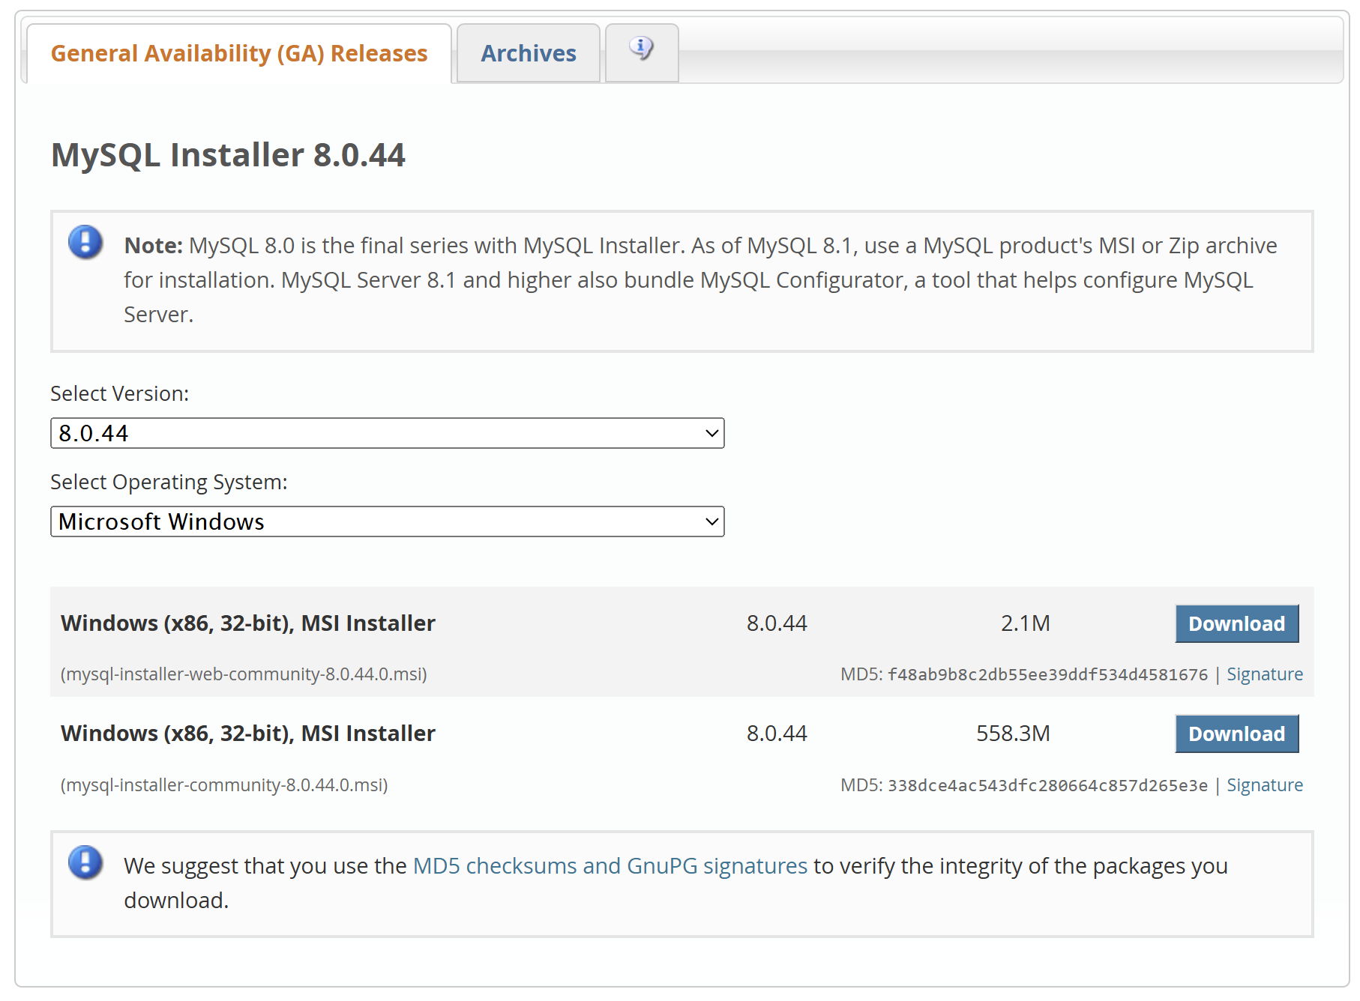
Download the 2nd option.

Installation and Configuration of MySQL Server
Open the downloaded file and follow the instruction as shown in screenshots.

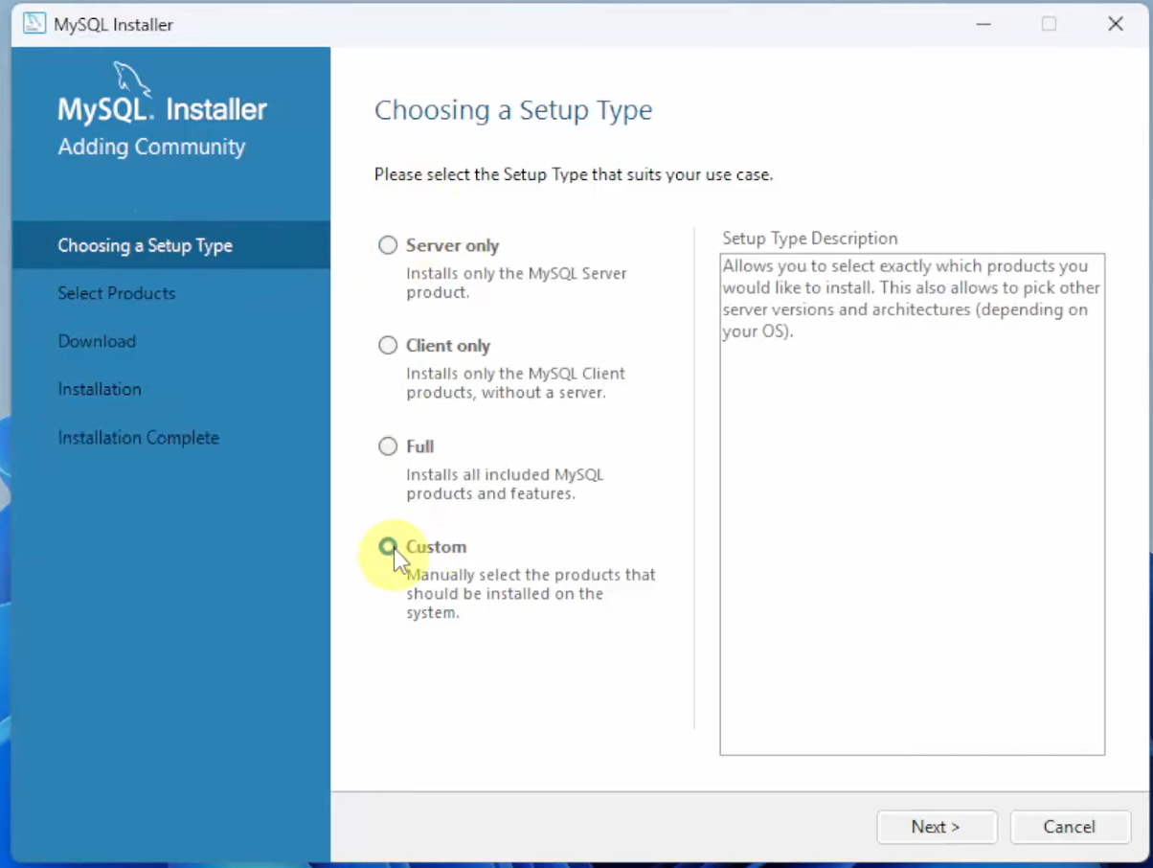
Select the Products as shown using the arrow mark.
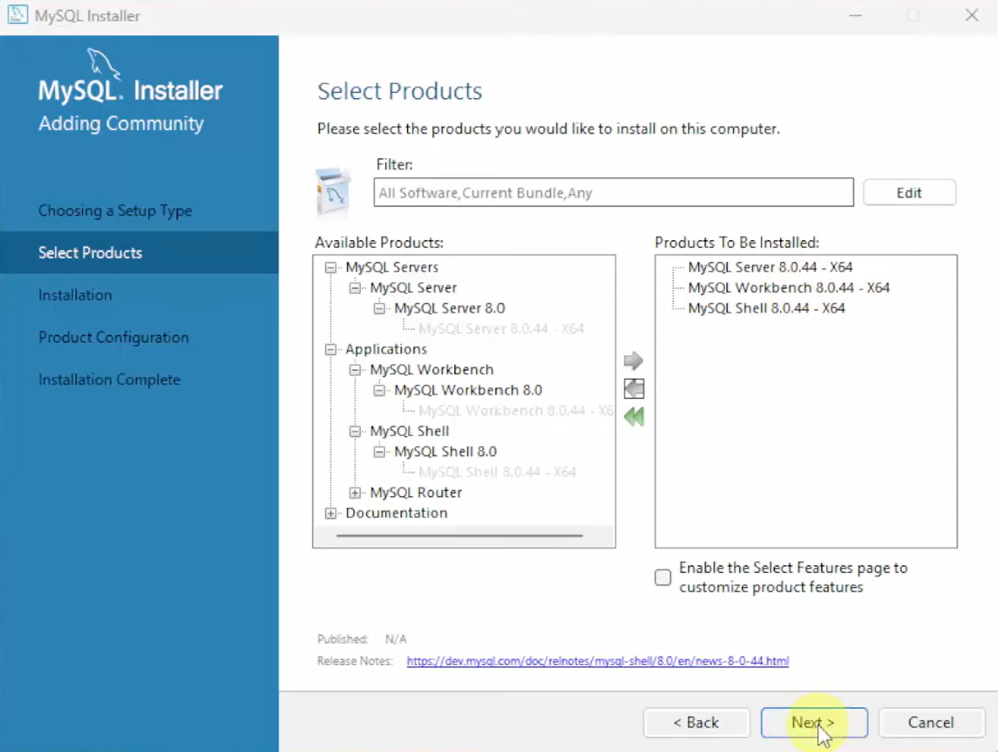

Click on “Execute” Button to begin installation of MySQL Products.
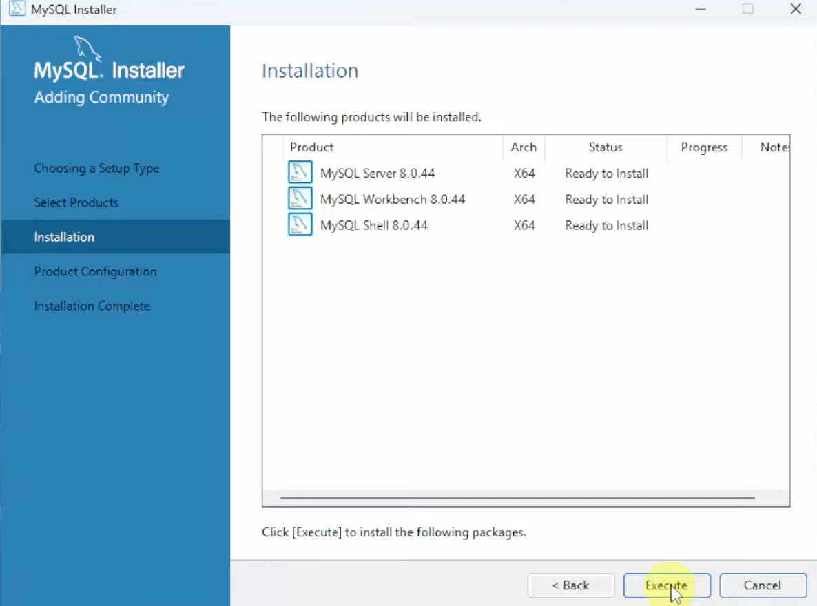
Green ticks show that products installed successfully.
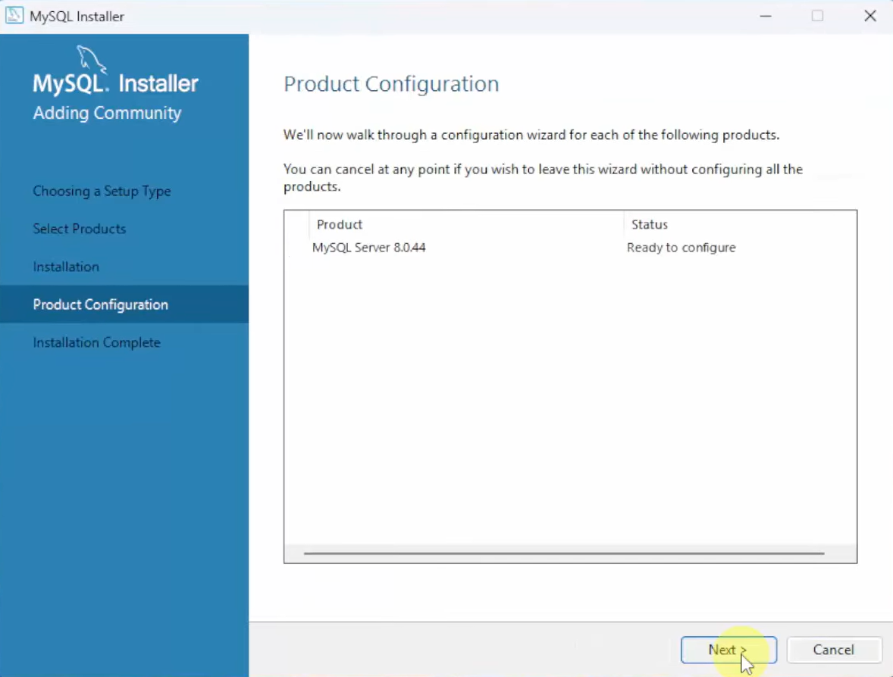
Next, we need to configure the MySQL Server and sample database. Click on next button.
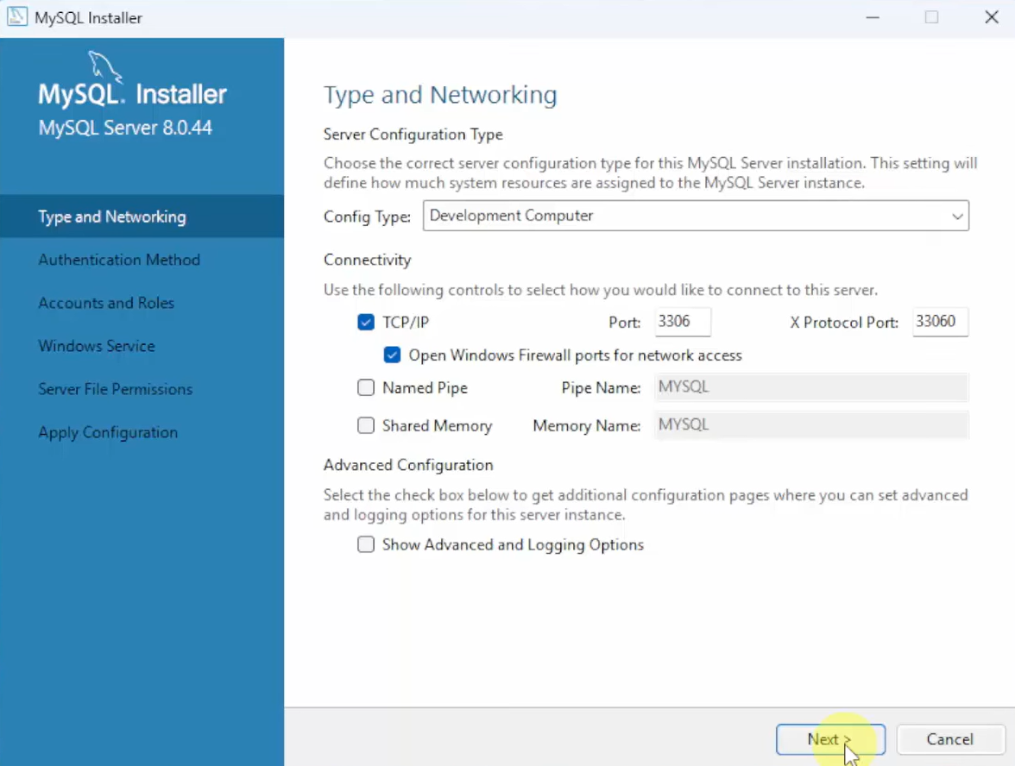
Keep it as such and click on “Next” button.
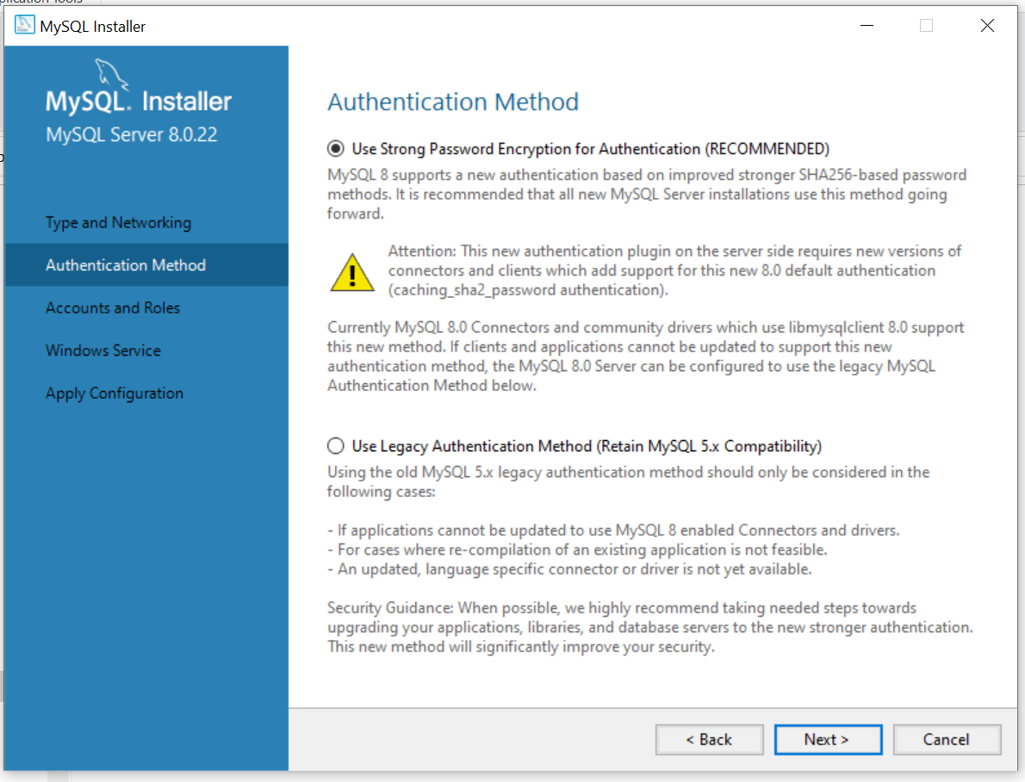
Click on “Next” Button.

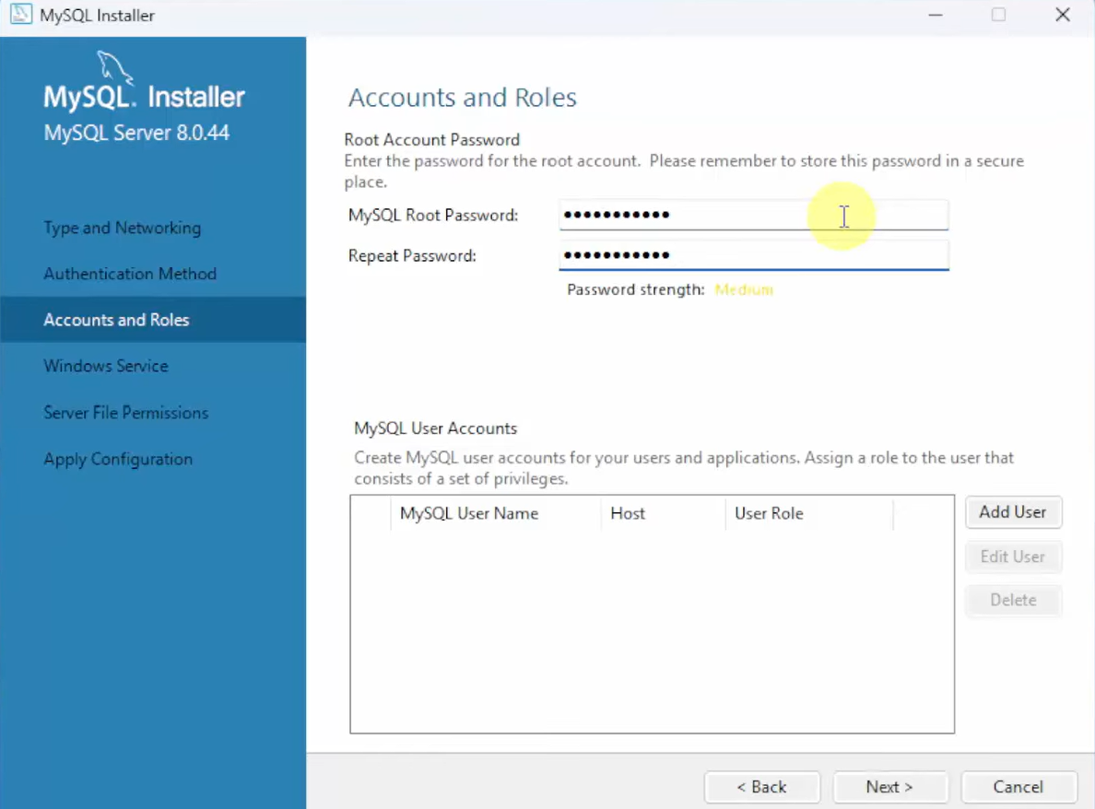
Choose a root password for MySQL server and not down it. It will require several times in future.

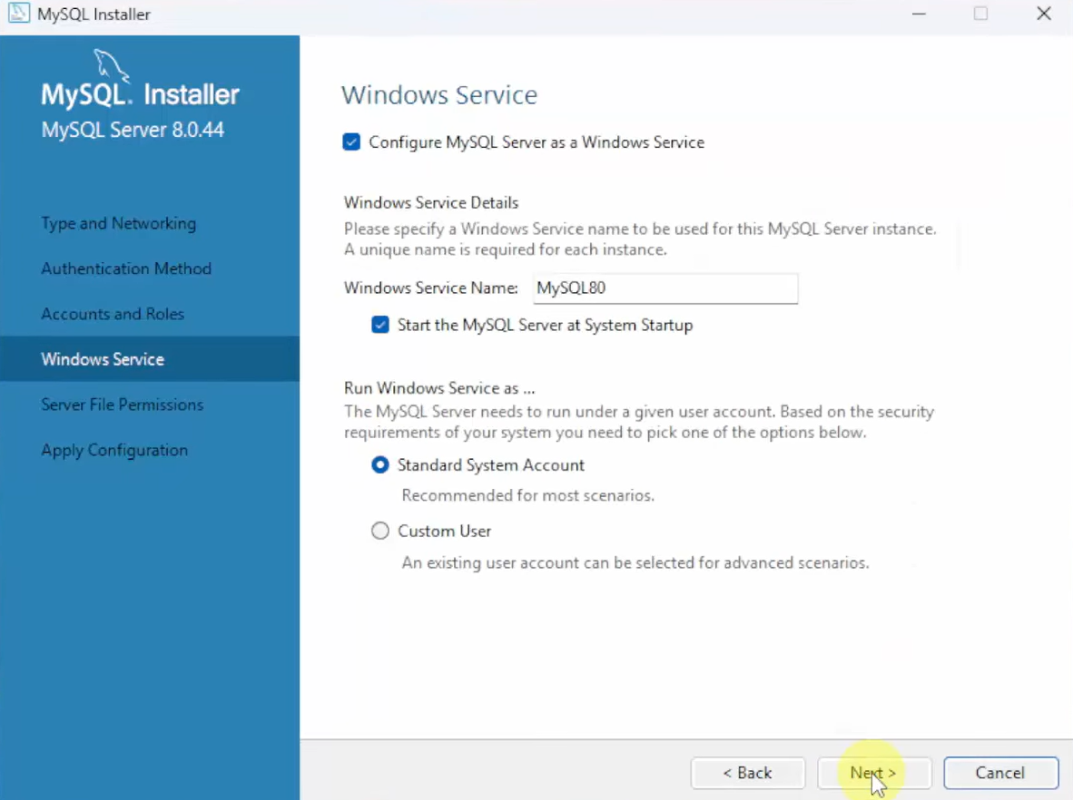
Keep it as such and click on “Next” button.
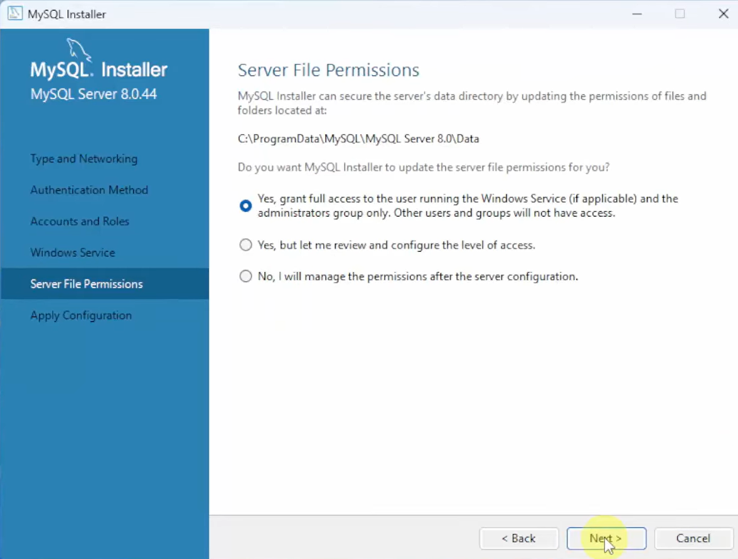
Keep it as such and click on “Next” button.
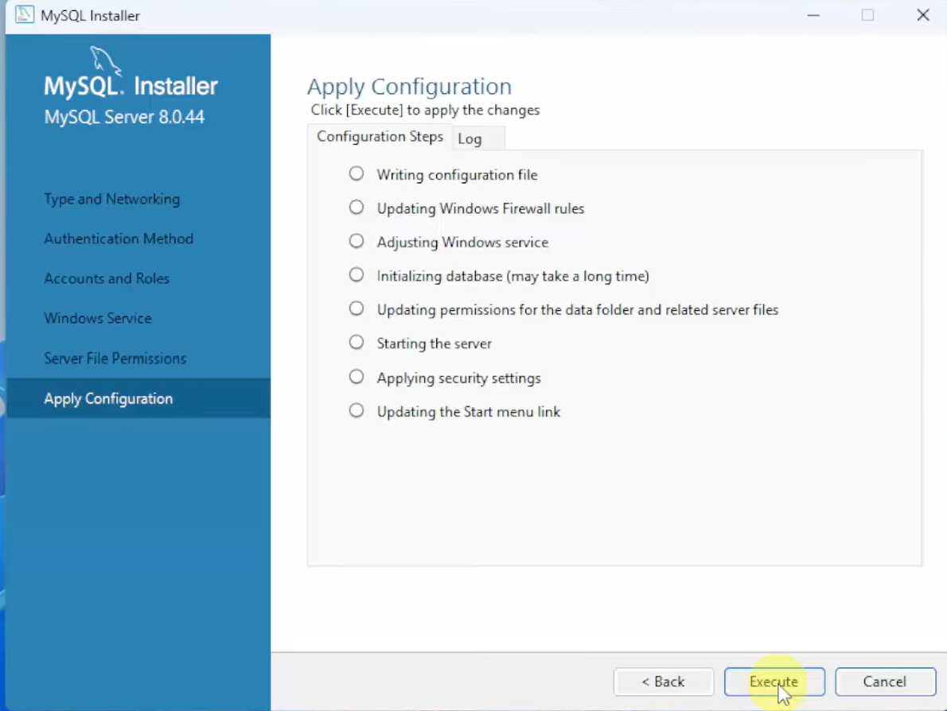
Click on “Execute” button to continue.
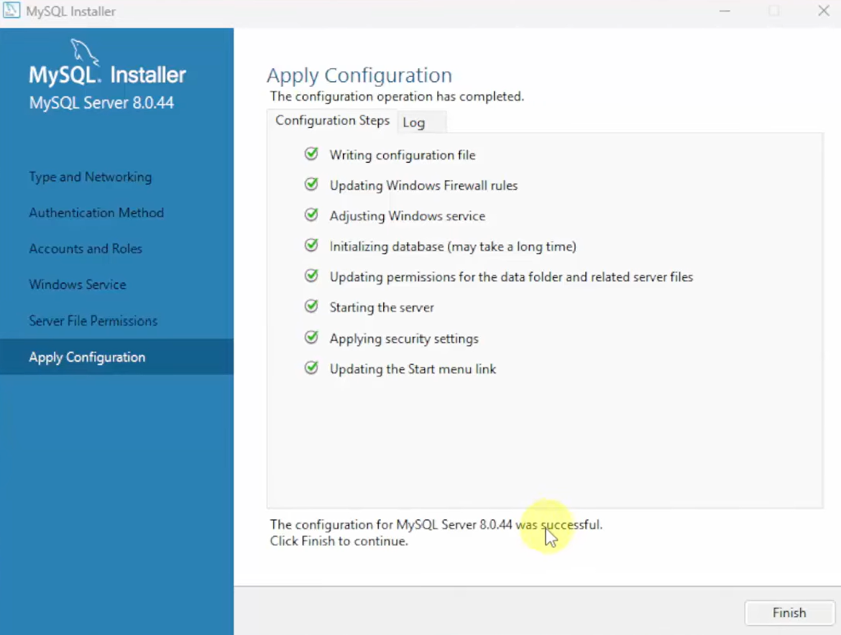
Click on “Finish” button to continue.

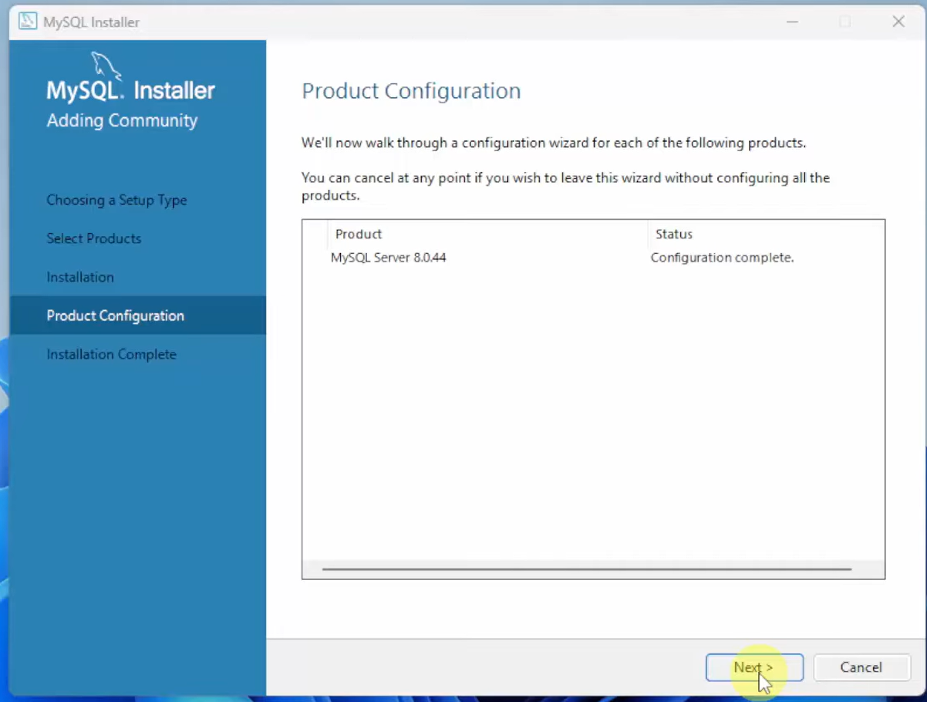
MySQL Server configuration completed. Now, click on “Next” button.

Click on “Finish” button.
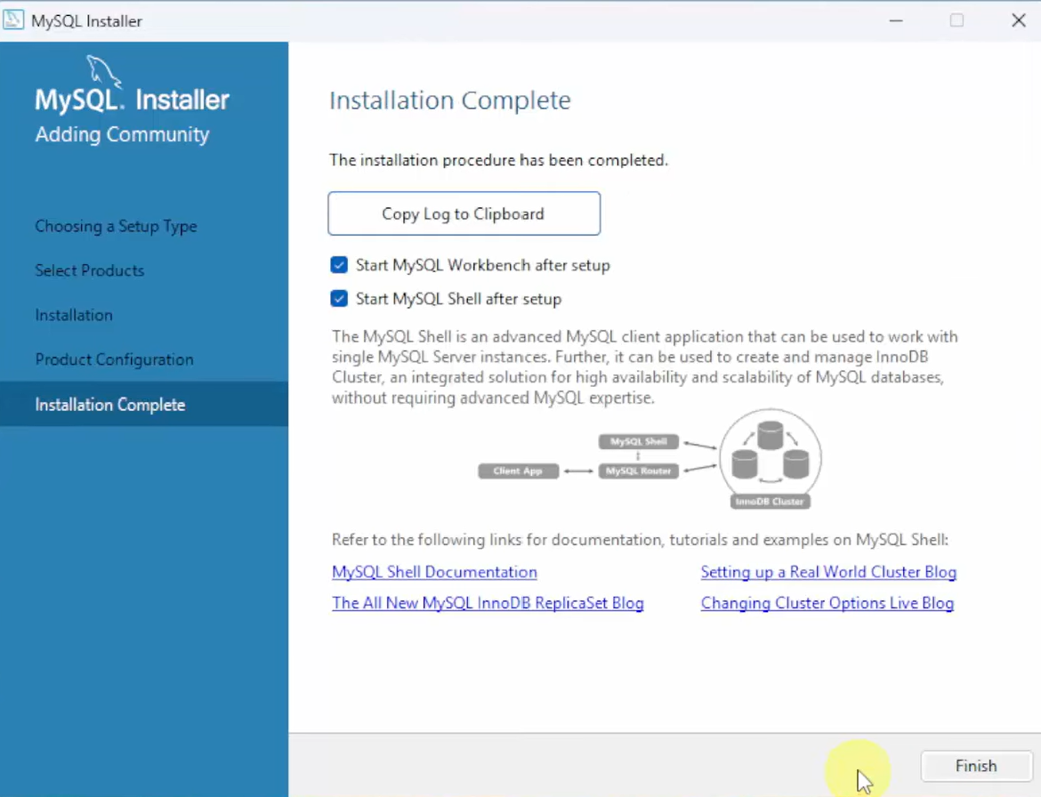

Now you have to set the path. For that navigate to the location where MySQL server bin file locates, copy the path and add it in the system environment variables.
If you have not modified the installation path, the path will be
C:\Program Files\MySQL\MySQL Server 8.0\bin
You can directly add it to the systems environment variables path.

Running SQL queries in MySQl Workbench

Open MySQL Workbench
Start Menu MySQL Workbench 8.0 CE.

Connecting to MySQL Server
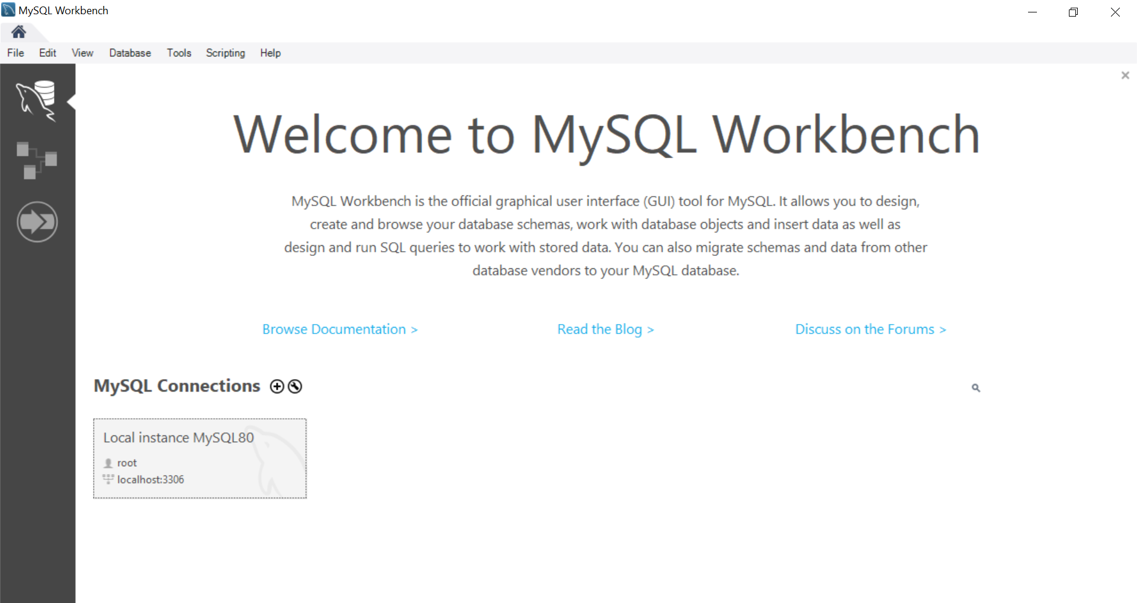
Click on area shown inside red color rectangle. A dialog box is opened asking for root password. Provide rood-password.
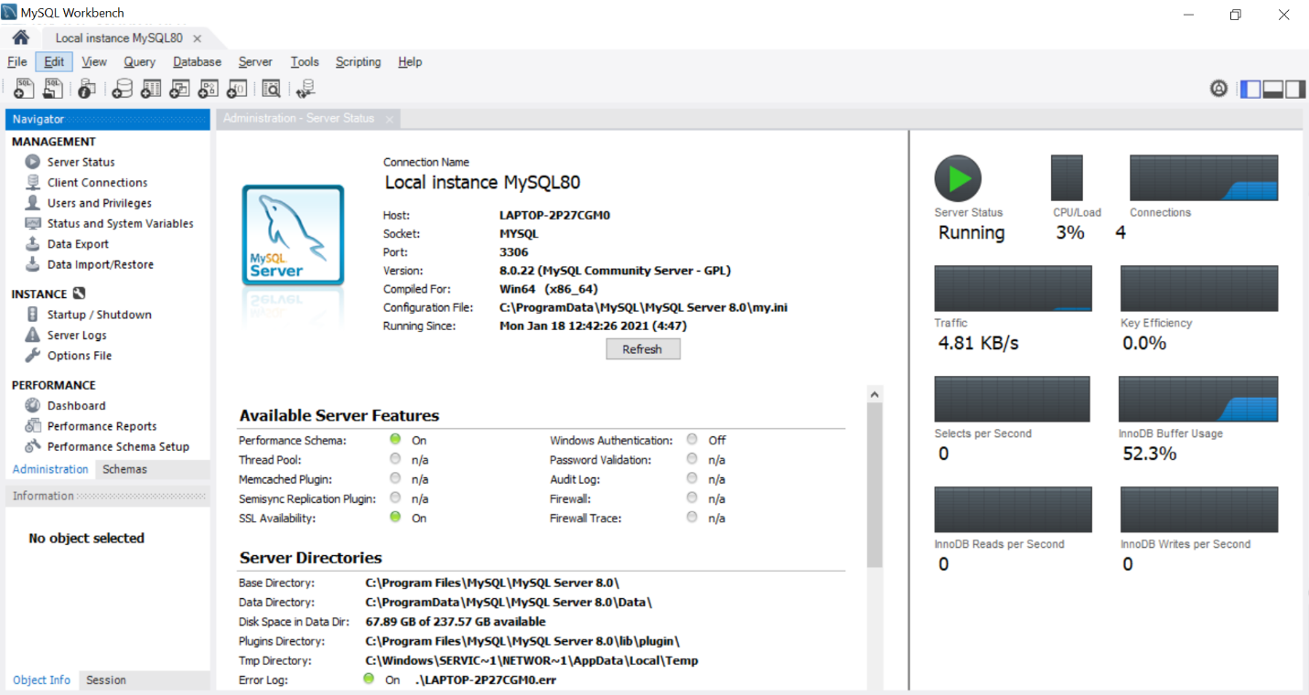
Check server status. If it shows “Running”, it means everything is installed and configured successfully.

Selecting Default Schema
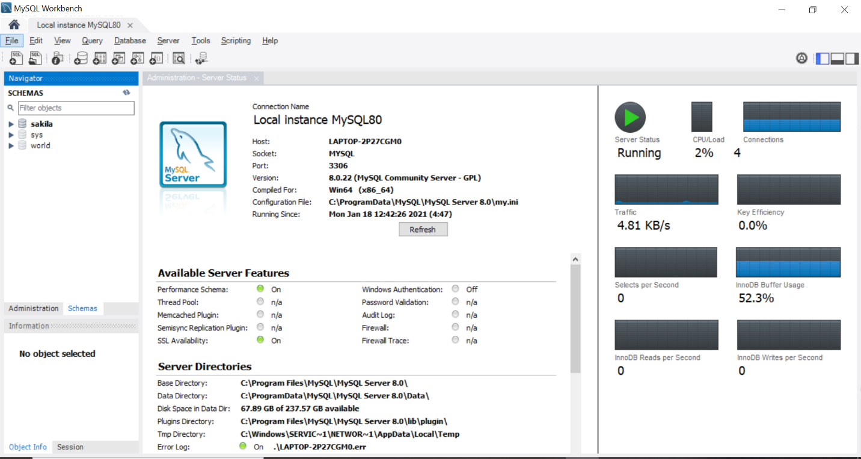
Click on “Schemas” in Navigator’s bottom pane. You will find three schemas created during installation. “Right Click” on schema name and select “Set as Default Schema”.

Writing and Executing SQL query
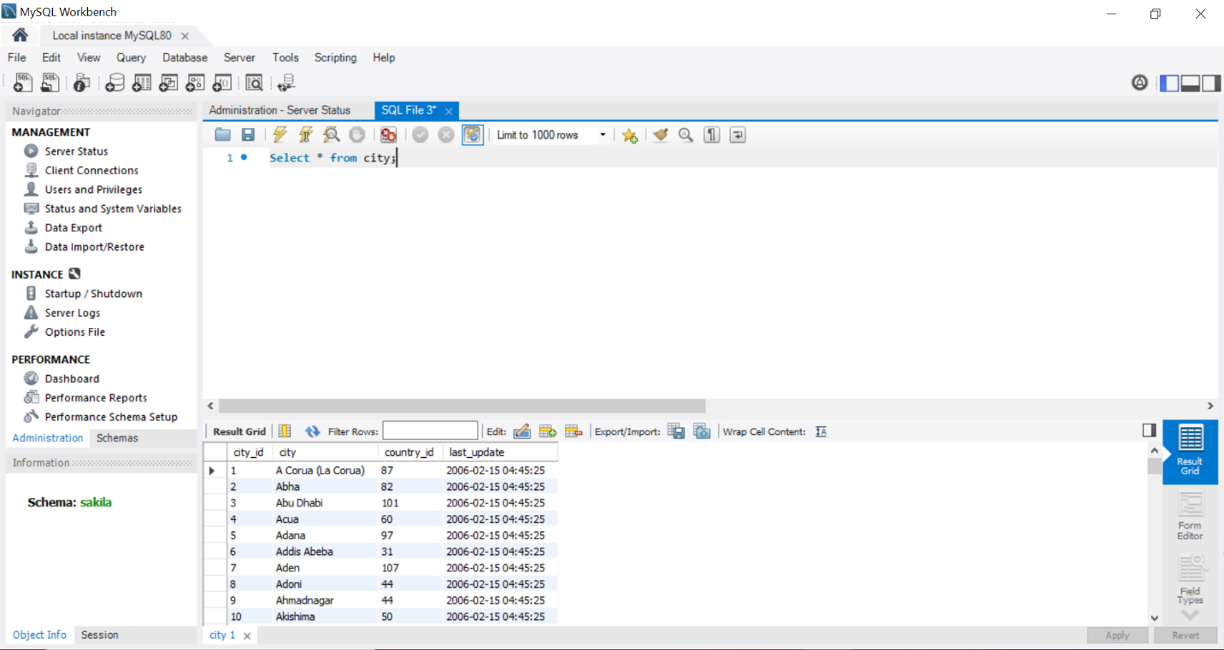
File New Query Tab or (Ctrl+T). Write “Select * from city” in workspace provided. Click on icon highlighted in red box to execute query. In this example “sakila” is selected as default schema.
***********************************END***************************************

